**Invoice Management Changes**

Screen 1: Inbox and related (1.1-1.5)

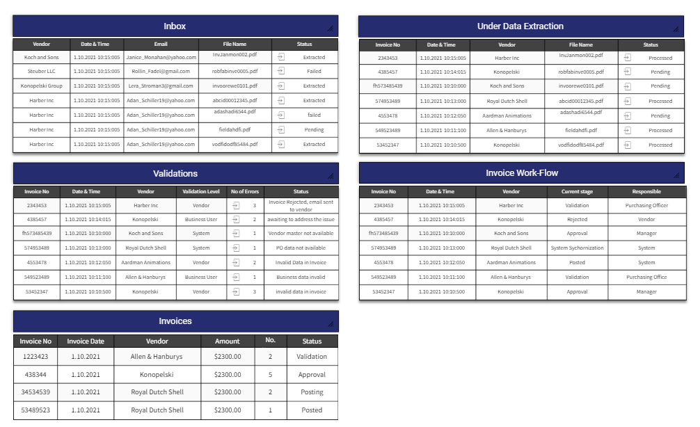

On screen 1 Inbox make click event on column

When click on validation then show screen 3 (validation) it’s a popup window which is scrollable.

otherwise click anywhere route to screen 2

Screen 2: Invoice comparison and editing

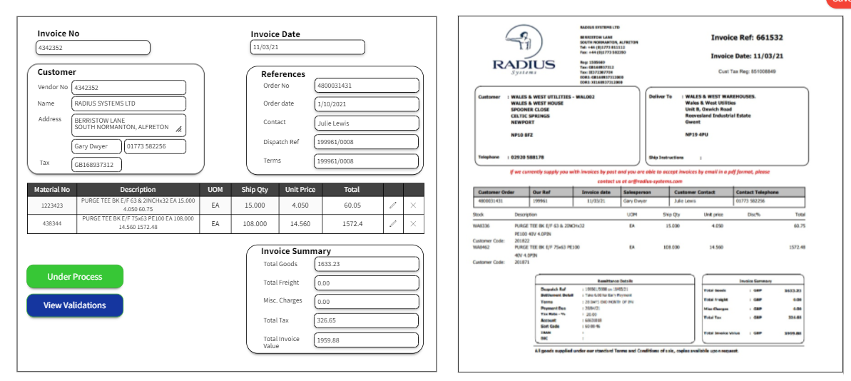

The fields should be editable i.e. user can change values manually.

The table has edit and delete icon so user can change values or delete entire row

Upon that changes the footer values are calculated as per given scenarios.

Note: Once the entry is deleted it is not retrieved nor updatable.

Invoice which is successfully validated and parsed (error free) is saved to our system for future scopes.

Screen 3: Validation Popup (it’s a popup window which is scrollable.)

Its open when click on particular row validation action

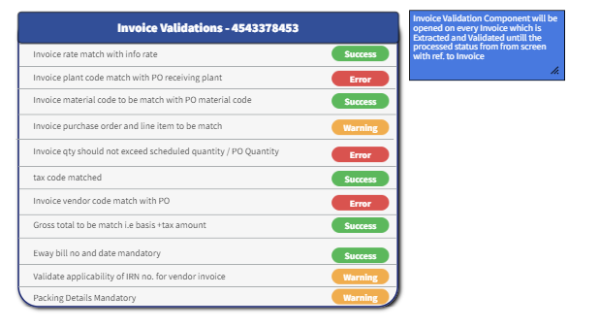

It has 3 color non clickable buttons (Success, Error, Warning).

It’s a scrollable popup having all validations related to invoice which is parsed.

Attached Data flow diagram for reference

